FREE LEARNING—Screenshots

Landing Page

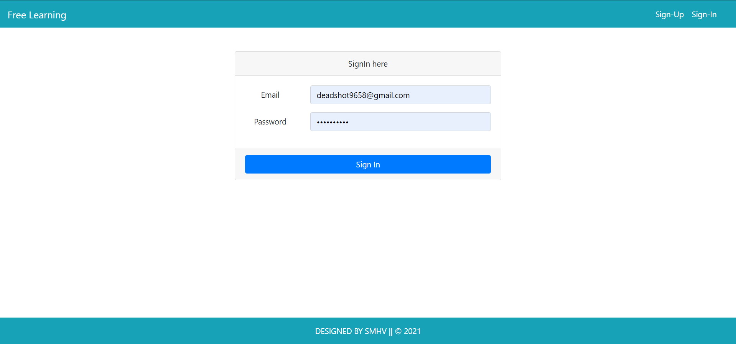

Home Pages

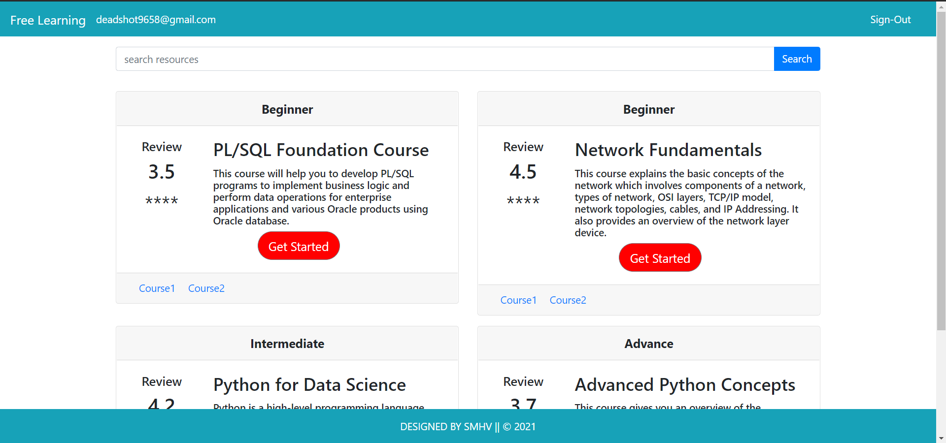

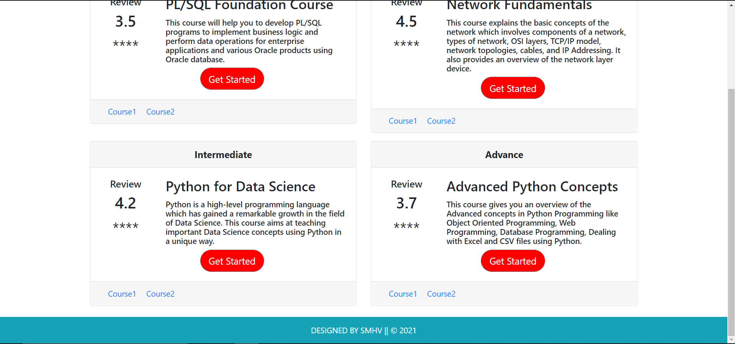

Links for every Specific Courses

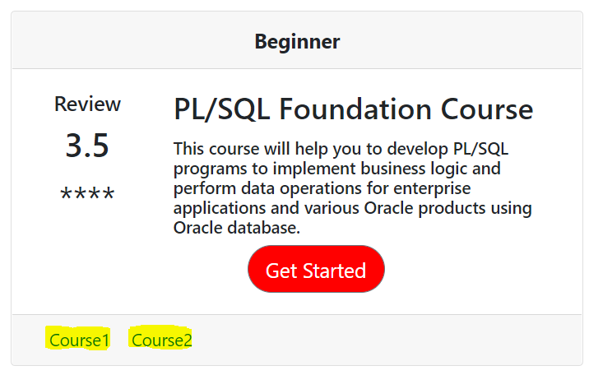

User Friendly for Starting or learning with the help of indications Beginner – Intermediate --- Advance

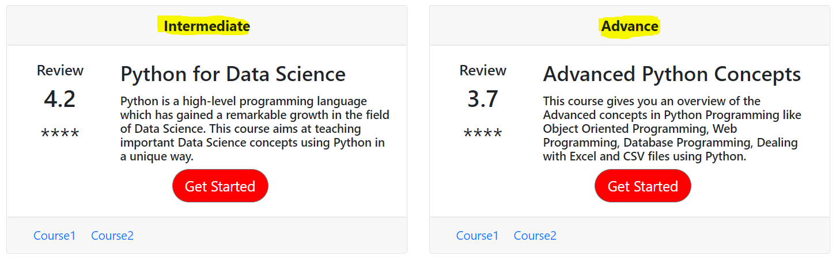

Nav Bar containing Details of the user when logged in ---- Sign-out Button



Reviews So that user can understand which courses in Demand, or which are best in the Site

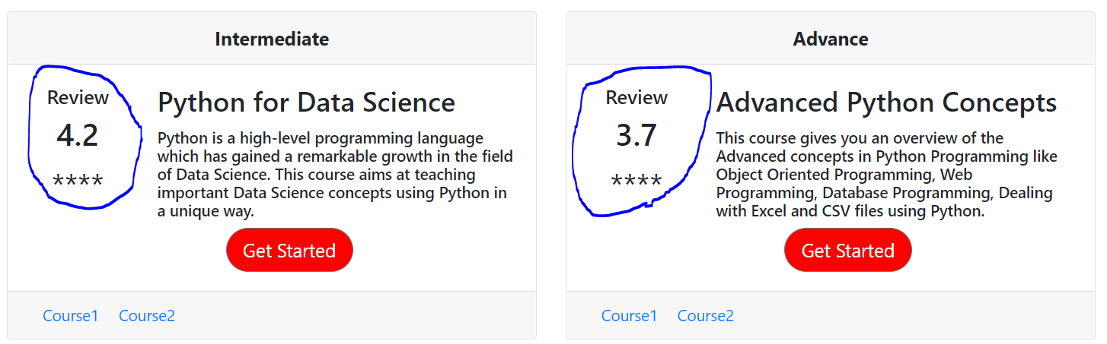

Will Get Warning pop ups on entering wrong Credentials?

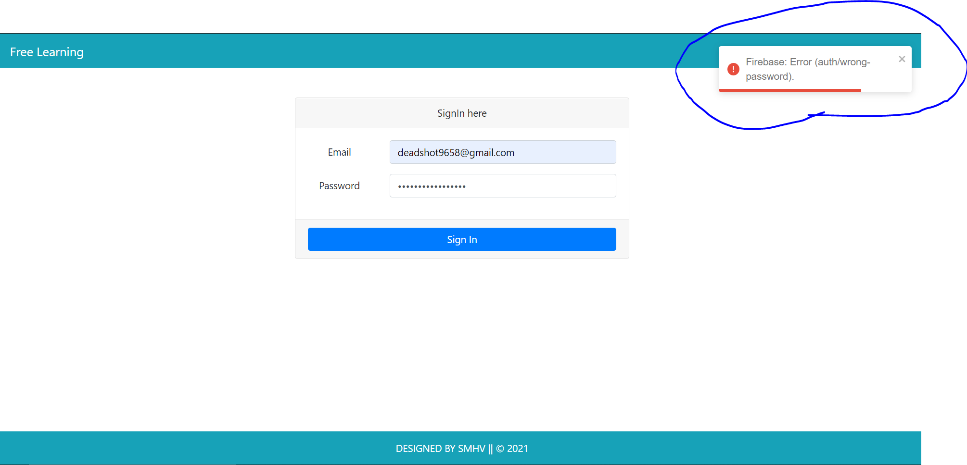

Can Sign Up with any type of mail Id and passwords

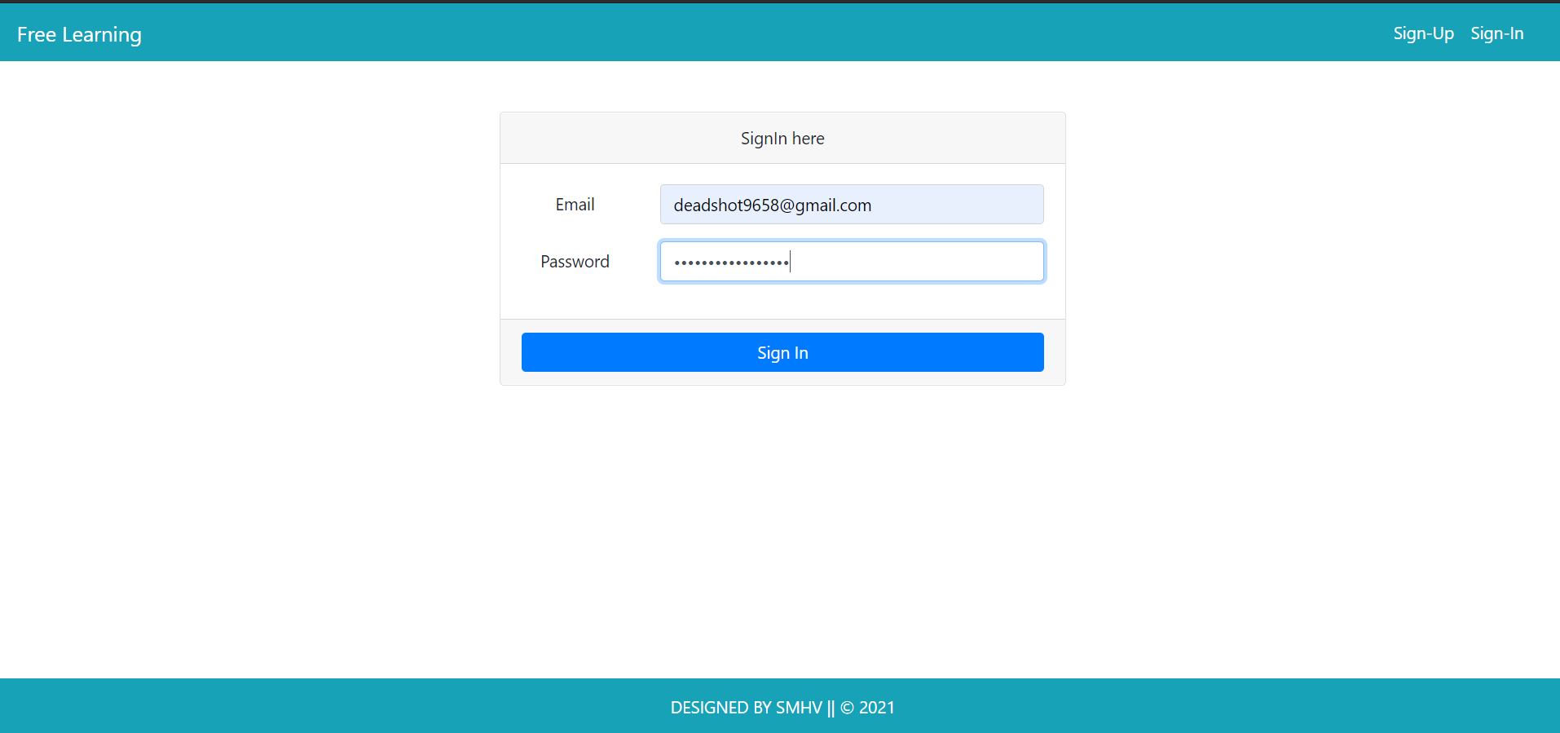

HOSTED LINK OF THE SITE: freelearningdemo.netlify.app

THANK YOU